**RSA Public-Key Encryption and Signature Lab**

**Task 1: Deriving the Private Key**

#include<stdio.h>

#include<openssl/bn.h>

#define NBITS 512

void printBN(char *msg, BIGNUM *a)

{

char * number_str = BN_bn2hex(a);

printf("%s %s\n", msg, number_str);

OPENSSL_free(number_str);

}

int main ()

{

BN_CTX *ctx = BN_CTX_new() ;

BIGNUM *p = BN_new() ;

BIGNUM *q = BN_new() ;

BIGNUM *e = BN_new() ;

BIGNUM *d = BN_new() ;

BIGNUM *n = BN_new() ;

BIGNUM *totient = BN_new() ;

BIGNUM *v = BN_new() ;

BIGNUM *b = BN_new() ;

BIGNUM *m = BN_new() ;

BN_hex2bn(&p, "F7E75FDC469067FFDC4E847C51F452DF");

BN_hex2bn(&q, "E85CED54AF57E53E092113E62F436F4F");

BN_hex2bn(&e, "0D88C3");

BN_hex2bn(&m, "0001");

BN_sub(v, p,m);

BN_sub(b, q,m);

BN_mul(n, p, q, ctx);

printBN("p * q = ", n);

BN_mul(totient, v, b, ctx);

printBN("totient = ", totient);

BN_mod_inverse(d, e, totient, ctx);

printBN("d = e-1 mod totient =", d);

return 0;

}

**OUTPUT:**

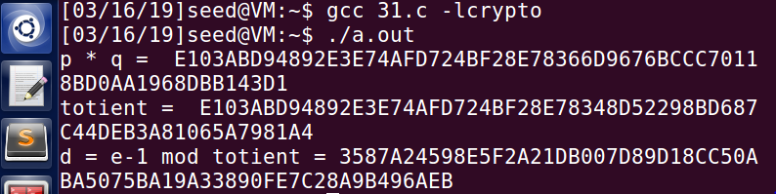

**Task 2: Encrypting a Message**

**Using the python command for encryption, I got the following output:**

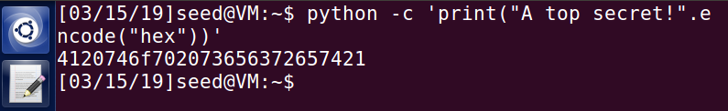

**Using a C code for the same task, I was able to fetch the following output:**

#include<stdio.h>

#include<openssl/bn.h>

#define NBITS 512

void printBN(char *msg, BIGNUM *a)

{

char * number_str = BN_bn2hex(a);

printf("%s %s\n", msg, number_str);

OPENSSL_free(number_str);

}

int main ()

{

BN_CTX *ctx = BN_CTX_new() ;

BIGNUM *n = BN_new() ;

BIGNUM *e = BN_new() ;

BIGNUM *M = BN_new() ;

BIGNUM *C = BN_new() ;

BN_hex2bn(&n, "DCBFFE3E51F62E09CE7032E2677A78946A849DC4CDDE3A4D0CB81629242FB1A5");

BN_hex2bn(&e, "010001");

BN_hex2bn(&M, "4120746f702073656372657421");

BN_mod_exp(C,M,e,n,ctx);

printBN("C = M^e mod n", C);

return 0;

}

**OUTPUT:**

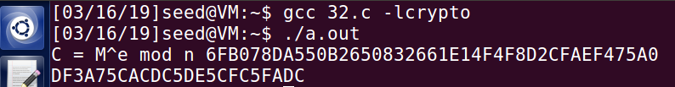

**Task 3: Decrypting a Message**

**Using the python code for decryption, the following output was observed.**

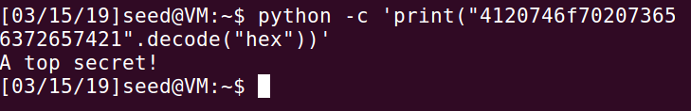

**Using a C code for the same task with the hex value “4120746f702073656372657421”, I was able to fetch the following output:**

#include<stdio.h>

#include<openssl/bn.h>

#define NBITS 512

void printBN(char *msg, BIGNUM *a)

{

char * number_str = BN_bn2hex(a);

printf("%s %s\n", msg, number_str);

OPENSSL_free(number_str);

}

int main ()

{

BN_CTX *ctx = BN_CTX_new() ;

BIGNUM *p = BN_new() ;

BIGNUM *q = BN_new() ;

BIGNUM *e = BN_new() ;

BIGNUM *d = BN_new() ;

BIGNUM *n = BN_new();

BIGNUM *M = BN_new() ;

BIGNUM *C = BN_new() ;

BN_hex2bn(&d, "74D806F9F3A62BAE331FFE3F0A68AFE35B3D2E4794148AACBC26AA381CD7D30D");

BN_hex2bn(&n, "DCBFFE3E51F62E09CE7032E2677A78946A849DC4CDDE3A4D0CB81629242FB1A5");

BN_hex2bn(&C, "8C0F971DF2F3672B28811407E2DABBE1DA0FEBBBDFC7DCB67396567EA1E2493F");

BN_mod_exp(M,C,d,n,ctx);

printBN("M = C^d mod n =", M);

return 0;

}

**OUTPUT**

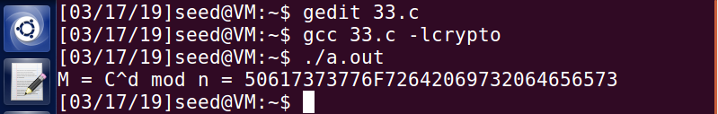

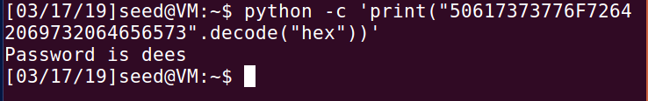

**3.4 Task 4: Signing a Message**

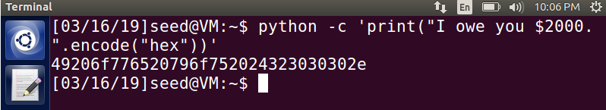

#include<stdio.h>

#include<openssl/bn.h>

#define NBITS 512

void printBN(char *msg, BIGNUM *a)

{

char * number_str = BN_bn2hex(a);

printf("%s %s\n", msg, number_str);

OPENSSL_free(number_str);

}

//49206f776520796f75202433353633

int main ()

{

BN_CTX *ctx = BN_CTX_new() ;

BIGNUM *s = BN_new() ;

BIGNUM *M = BN_new() ;

BIGNUM *d = BN_new() ;

BIGNUM *e = BN_new() ;

BIGNUM *n = BN_new() ;

BN_hex2bn(&M, "49206f776520796f752024323030302e");

BN_hex2bn(&d, "74D806F9F3A62BAE331FFE3F0A68AFE35B3D2E4794148AACBC26AA381CD7D30D");

BN_hex2bn(&n, "DCBFFE3E51F62E09CE7032E2677A78946A849DC4CDDE3A4D0CB81629242FB1A5");

BN_mod_exp(s,M,d,n,ctx);

printBN("Signature = M^d mod n = ", s);

return 0;

}

**OUTPUT:**

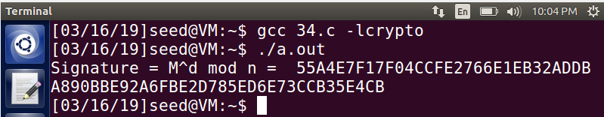

Changing the message from $2000 to $3000 results in the following observation:

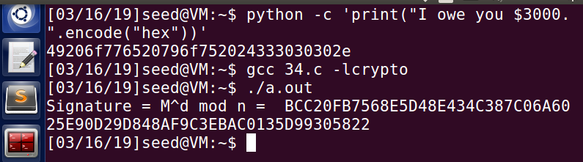

The above snapshot clearly depicts that changing the message slightly results in a completely different signature without adding any additional bits to the signature.

**3.5 Task 5: Verifying a Signature**

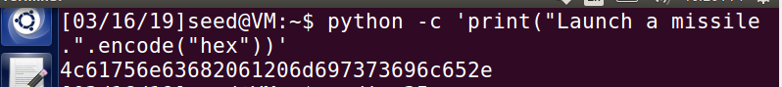

#include<stdio.h>

#include<openssl/bn.h>

#define NBITS 512

void printBN(char *msg, BIGNUM *a)

{

char * number_str = BN_bn2hex(a);

printf("%s %s\n", msg, number_str);

OPENSSL_free(number_str);

}

//4c61756e63682061206d697373696c652e

int main ()

{

BN_CTX *ctx = BN_CTX_new() ;

BIGNUM *s = BN_new() ;

BIGNUM *M = BN_new() ;

BIGNUM *d = BN_new() ;

BIGNUM *e = BN_new() ;

BIGNUM *n = BN_new() ;

BN_hex2bn(&s, "643D6F34902D9C7EC90CB0B2BCA36C47FA37165C0005CAB026C0542CBDB6803F");

BN_hex2bn(&e, "010001");

BN_hex2bn(&n, "AE1CD4DC432798D933779FBD46C6E1247F0CF1233595113AA51B450F18116115");

BN_mod_exp(M,s,e,n,ctx);

printBN("M = s^e mod n = ", M);

return 0;

}

**OUTPUT:**

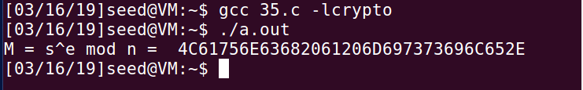

Changing the last byte of the signature from 2F to 3F adds 20 more bits and results in a totally different message as shown in the snapshot below:

